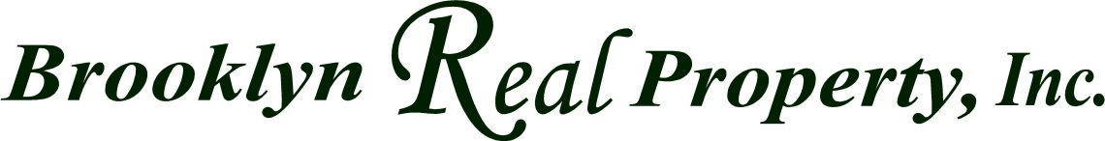
INVOICE
Dated:

Reg:

License#

This document acknowledges as an invoice/receipt for the service rendered and being the
procuring cause bringing about the meeting of the mind for the sale purchase of
____________________________________________ located in New York ______________
between ________________________________ (as purchaser) and ______________________
__________________________(as seller). The amount of ______________________________
________________($ ) USD will be paid by PURCHASER to Brooklyn Real Property, Inc.
at the time closing or title exchange.
This is a co broke between _______________________ and Brooklyn Real Property, Inc. and
_________________________ acknowledges Brooklyn Real Property, Inc. as a subagent is
acting as sellers agents accordingly to article 12A.
This document is inclusively & exclusively to this transaction only!

________________________________________ __________________________________ Purchaser Client Buyer’s agent

_____________________________________________ Co Broker Real Estate Firm

